Project plan

mCon Rebound multiplayer
  - mCon esports
Rotterdam

Date | 08-05-2025
Version | 0.2
State | Unpublished
Authors | Sander Theeuwen

Contents
Revision history 3
Distribution 3
Project assignment 4
Context 4
Goal of the project 4
Assignment 4
Scope 4
Preconditions 4
Strategy 5
Research questions 5
End products 5
Project organization 6
Stakeholders and team members 6
Communication 6
Activities and time plan 7
Phases of the project 7
Testing strategy and configuration management 8
Testing strategy 8
Test environment and required resources 8
Configuration management 8
Finances and risks 9
Project budget 9
Risk and mitigation 9

Revision history
Version | Date | Authors | Changes | State
0.1 | 06-05-2025 | Sander Theeuwen | Created document.  Added project assignment.  Added project organization.  Added activities and time plan.  Added testing strategy and configuration management.  Added finances and risks. | Unpublished
0.2 | 08-05-2025 | Sander Theeuwen | Added current state of the game.  Expanded document to revised focus on LAN multiplayer rather than connection over Steam.  Added time plan. | Unpublished

Distribution
Version | Date | Receivers

Project assignment

Context
mCon esports is a company that provides tournaments for esports competitors to test their skills in various games. They have their own space to hold these tournaments with several dozens of spaces for the players. The core team consists of 8 members, there are daily around 35 to 40 employees working, and at events there are 80+ people who help.
mCon has created one project before, a simple web game, but this project is the first big project they are working on themselves.

Current state of the game
The current product is fully functional, but only supports same-screen multiplayer. The game’s functionalities are balanced and tested, including a lobby and several levels as seen in Figures 1 and 2. The models are low poly, have animations like attacks, dodges and victories.
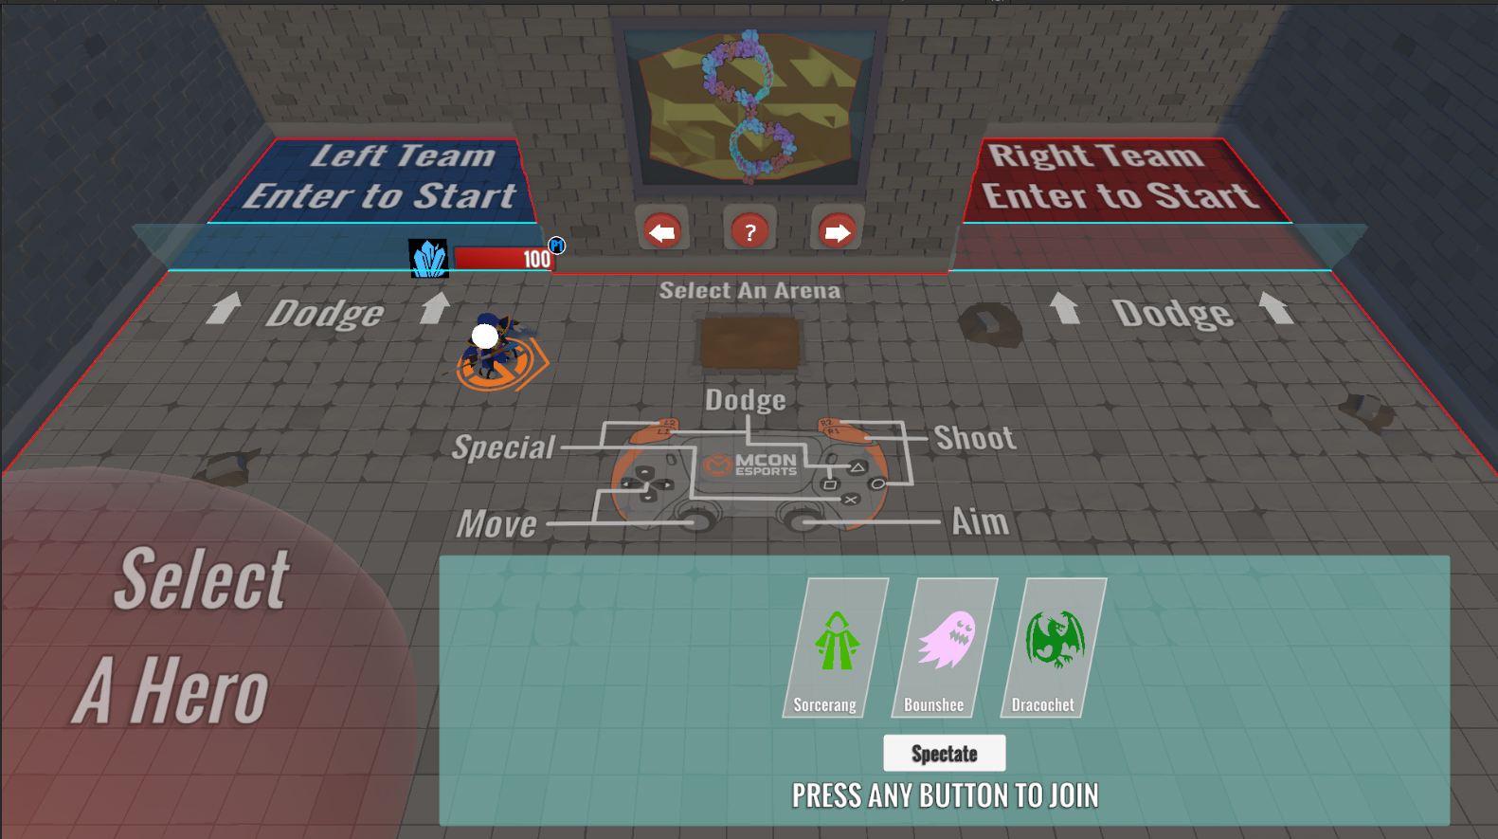
Figure 1 Hero selection
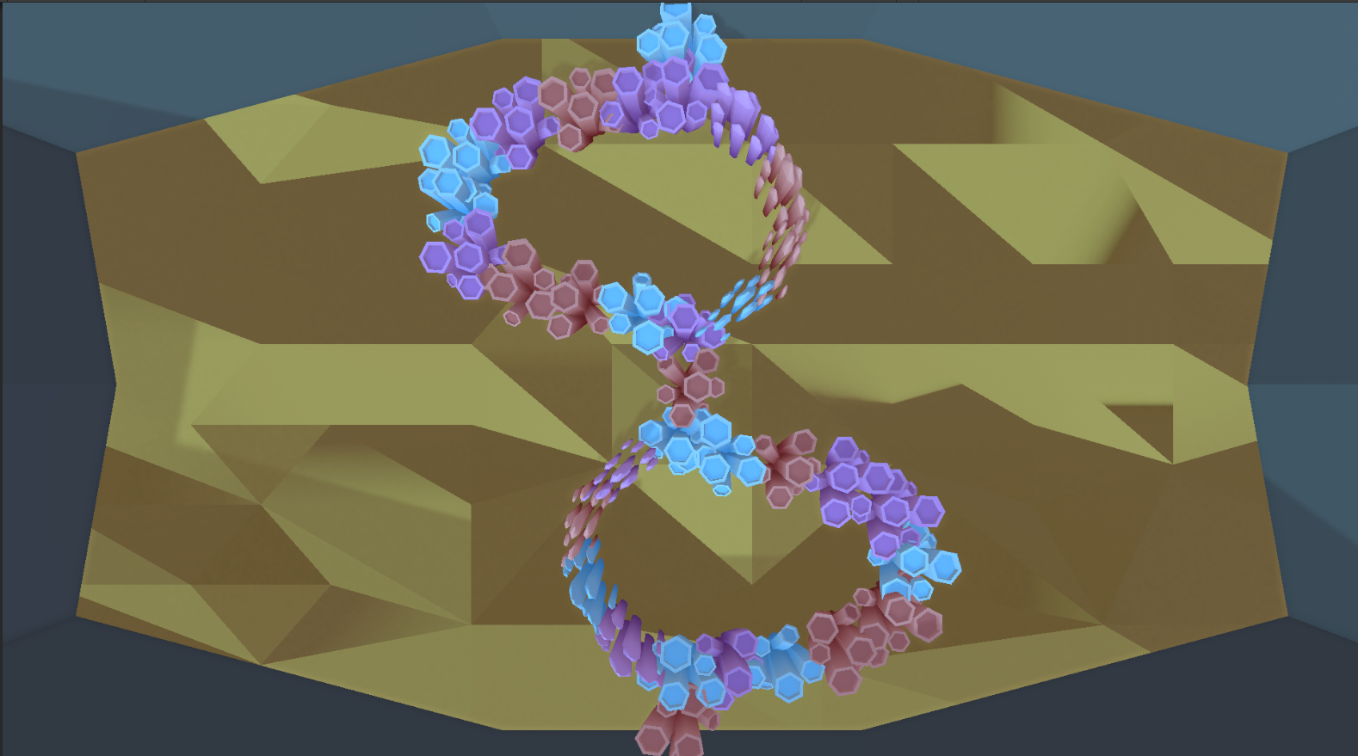
Figure 2 Level "Invasion"
The developer indicated that the UI has not been tested and needs tweaking, which they will work on while the project is extended to multiplayer over LAN.aw

Goal of the project
As there is a large gap between casual gaming and esports, mCon esports aims to narrow this gap. To give the fans of mCon something to be excited about, mCon decided to create their own game rather than simply use an existing game. This will also be beneficial for the brand of mCon, as there is currently an mCon universe in creation that will eventually be added to the game. The game was created by Kayleigh Westerweele, a graduate student from Fontys, who delivered a finished game that is designed for 2 players but has spawn locations for 6. The goal of the project is to expand this multiplayer feature to support many more players, as mCon has space for around 50 players.
In the desired situation, mCon can set up the game on LAN and the players can join using the PCs at the esports space in the same room. Therefore, this game is designed to be played at mCon, publicly accessible through their events.
The project’s unique selling points are simplicity with a challenge: The core components of the game are easy to understand, which is enough of a skill ceiling to make the game challenging to be good at. With the multiplayer feature, the requirement of a high skill ceiling keeps players interested in the game, as they have the intrinsic motivation to become the best.
The product will contain the colors of mCon esports to promote the company in terms of branding.

Assignment
mCon Rebound will work as follows: The players will each select a hero to play as and will step into the ‘start zone’, marked with a color in the playing field. When every player is in the start zone, the game will load a random map, and the players are spawned. The playing field is divided into two halves separated by a wall with each team occupying one half. If there are multiple players in a team, they will be scattered among the team’s half. When the game starts, the players can shoot projectiles at each other or the environment. The environment causes the projectiles to ricochet, causing a bullet hell experience where it requires skill to both dodge the incoming hazards and to overwhelm the opponent(s). Each player’s hero has an ability that can be used as either offense or defense. These abilities vary per hero. When all characters of a team are eliminated, the surviving team wins.
The design challenge for the game is as follows:
Extend a medium fidelity same-screen multiplayer game to support multiplayer over LAN for players aged 10 to 50 that attend events like Heroes Dutch Comic Con and TwitchCon that mCon wants to introduce to esports to let the players experience an esports environment, so they are encouraged to go to mCon tournaments / events.

Scope
Inside scope | Outside scope
Project plan | Additional character creation
Game design document | Models and textures
Test report | Connection through Steam
Research document
Support for multiple players
Connection through LAN

Preconditions
The project will be developed in Unity using C#. This is because the existing project also uses this technology.
The existing low fidelity game is fully functional but requires some polishing, which will be done by Kayleigh Westerweele.

Strategy
The project will be developed using the Scrum agile approach. At the start of the project, extensive research will be done to decide the best way for implementing multiplayer. When this decision is made, the multiplayer feature will be implemented and tested in an iterative approach, ensuring quality and validation of functionality. As the multiplayer feature is added, the project will be polished according to the client’s needs.

Research questions

What is the most suitable way to expand the existing game for multiplayer?

What existing multiplayer options already exist?
I will start by using literature study combined with available product analysis to search for myself what options are out there and how they work to get a small overview of the most popular frameworks / technologies.
I will then use expert interviews with former classmates who worked on multiplayer projects before asking what their experience was, to discover pros and cons of specific technologies so I can decide on what to use for this project.

Which of the already existing options are suitable for the game?

If multiple options are suitable for the game, would it be possible and viable to combine these options?
This will heavily depend on literature study, as it is more of a technical question whether it is even possible and efficient to combine multiple options. I can use community research to discover if developers did this before and whether it is good practice.

If multiple options are suitable, but not possible or viable to combine, which option is most suitable for the game?
I will perform a product analysis to see the potential bottlenecks of the game, then based on stakeholder analysis where I will learn what the most important aspects of the multiplayer functionality are (like latency, thoroughness, etc.) I will decide on what would be most suitable. If need be, I can use literature study or community research to support in making this decision.

How can the most suitable multiplayer option be implemented in the game in Unity?
If I know people who used the decided option, I can ask them how they implemented it. I can also use literature study and community research to learn. To ensure the quality of the implementation, I will use peer reviews to get tips on how to optimize my code. I will also perform static program analysis, suspectedly by using the debug mode in the editor, to see how efficient the code is and to spot and fix / mitigate potential bottlenecks.

End products
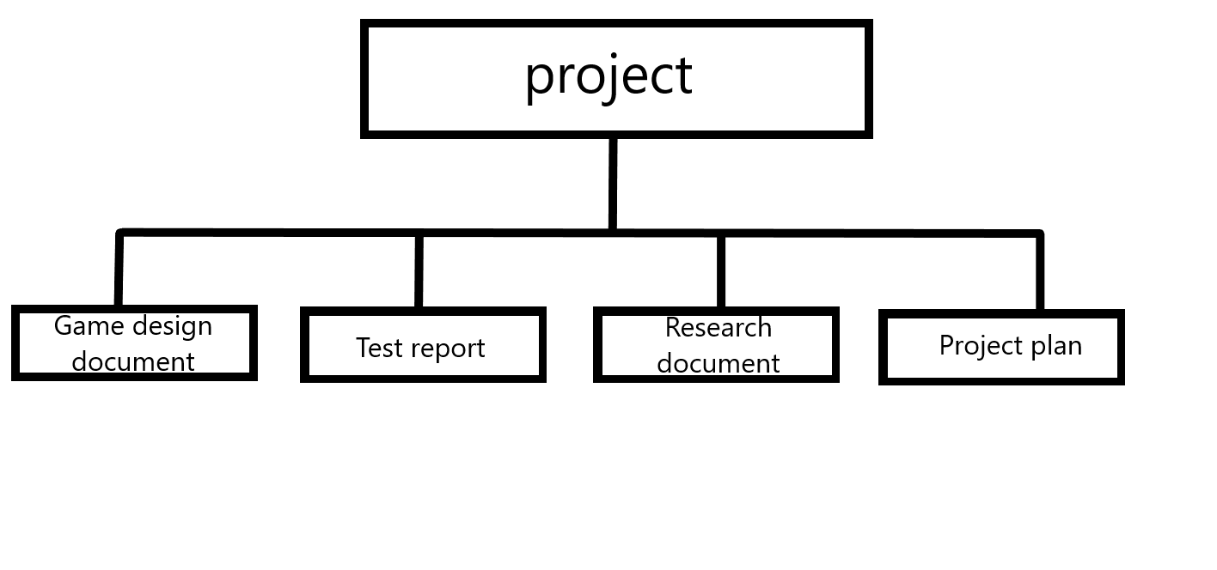Game design document:
The document where all details concerning design and mechanics of the game are listed and elaborated.
Test report:
A compilation of the tests and the results, how and when the tests were performed and what was tested.
Research document:
The research that will be done during the development of the project.
Project plan:
This document contains the details about the assignment.

Project organization

Stakeholders and team members
Name | Abbreviation | Role and functions | Availability
Sander Theeuwen  s.theeuwen@student.fontys.nl  +31 6 10433821 |  | Scrum master.  Developer.  Product owner. | Monday: 9.00  17.00  Tuesday: 9.00  17.00  Wednesday: 9.00  17.00  Thursday: 9.00  17.00  Friday: 9.00  17.00  Saturday: -  Sunday: -
Ruben Been  ruben@mconesports.com  +31 6 51703950 |  | Client.  Company mentor. | Contact through MS Teams
Kayleigh Westerweele |  | Developer.
Michael Schifferlinng  m.schifferling@fontys.nl  +31 885086625 |  | Primary Fontys contact.  Assessor 1.  Semester coach. | Contact through email or MS Teams
End-users |  | Target group

Target group:
Players aged 10 – 50 who want to try out gaming in an esports setting.

Communication
For periodic feedback meetings, I can contact the company mentor through Whatsapp, though email is more professional. These requests for meetings will be sent long in advance. The project aims to have update meetings around every 3 weeks to make sure the client/company mentor is up to date.
MS Teams will be the way of communication with the Fontys assessors.
There will be a meeting with an assessor about the portfolio halfway through the semester.

Activities and time plan

Phases of the project
Project setup – 1 week:
This week will be around setting up the environment and organizational necessities like project planning, meeting organization (frequency / topics) and preparation for development.
Research – 4 weeks:
This phase will be focused on the research of the multiplayer feature to ensure the most suitable implementation and design is guaranteed.
First implementation, MVP – 3 weeks:
The multiplayer feature will be implemented into the existing game, this will be the minimal viable product.
Testing and further refinements, 6 weeks:
The product will be tested continuously and reiteratively improved upon.
Polishing – 3 weeks:
Some final changes to polish the product.
Finalization – 1 week:
The project will be prepared for delivery and the end presentation will be made.
Phasing | Effort | Time
Project setup |  | Week 1
Research |  | Week 2 – 5
First implementation |  | Week 6 – 8
Testing and further refinements |  | Week 9 – 14
Polishing |  | Week 15 – 17
Finalization |  | Week 18
After every phase, a retrospective is held to improve efficiency for the upcoming phases.

Testing strategy and configuration management

Testing strategy
The testing will mainly consist of observations and surveys to gather feedback from larger groups, while interviews and focus groups will be used to finetune the product during development.

Test environment and required resources
The game will be tested using the developer’s computer and potentially old classmates of the developer or employees at mCon esports.

Configuration management
A “main” branch will be used for deployments and will, together with the “develop” branch, have the latest updates. For every feature or standalone component, a new branch will be created from the “develop” branch and deleted when finished. Hotfixes will have their own branch, also branching from the “develop” branch.

Finances and risks

Project budget
The project does not have a set budget. All choices that lead to purchases will be thoroughly documented and then proposed to the client for review. The final decision for purchases will be made by the company mentor.
No purchases are expected to be required for the finished product.

Risk and mitigation
Risk | Prevention activities | Mitigation activities
The company mentor is unavailable for an extended period. | - | The Fontys contact will be informed. The project will continue to be developed.
The developer is unavailable for an extended period. | - | The company mentor and Fontys contact will be informed immediately, and the situation will be discussed.
Project gets terminated. | Ask for periodic feedback. | A different project can be started or resumed by the developer.
Git is unavailable. | - | The company mentor will be informed. The project is continued locally where different versions are saved in different locations.
Extended internet outage. | - | The developer will solely work on location.
Fontys contact judges the project has insufficient complexity. | - | A meeting will be held with the company mentor, the developer, and the Fontys contact to expand the project, so it has enough complexity.
Fontys contact decides the developer will not pass the semester. | Ask for feedback periodically. | The project will continue until the end of the semester.

